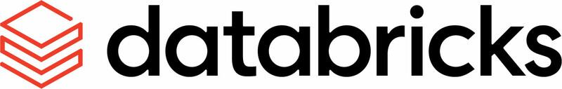

Welcome to Databricks! This may be your first time logging into the platform or you may already be familiar with Databricks, but either way there is plenty of resources here from learning pathways to workshops to blogs and more. Below you will find access to a variety of resources including those from our Help Center Learning Paths and our Databricks Training Academy.

Please reach out to the Account Team with any questions:
- Marc Harrell, Account Manager
- Nancy Shah, Solutions Architect
- Justin Boyd, Customer Success Engineer

By now, you probably have your login to Databricks. You can pursue some of the below courses to help you get started and learn more about Databricks and how it can help you in your role! Let’s get started!

Databricks Training Academy
Classes here up to the intermediate level are free to all Databricks customers and are geared to from newbies to professional users. So no matter what you level is there is a course for you! Some courses do provide accreditations / certifications. Now, the classes are updated regularly and sometimes new classes are added and older ones are replaced so check back when you need to learn more about Databricks.

Most courses are completely online, but there are a few that require you to download course notebooks and import them into Databricks. Course levels are marked with stars which represent the technical expertise needed to complete that course as defined below:
To identify what level a class is, the stars are shown as below:
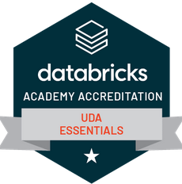


UDA Essentials is one star or an fundamental level course

To sign up, send an email to the Account team (email addresses linked above) with the following information so we can enroll you into the Databricks Academy:
- First Name (required)
- Last Name (required)
- Email Address (business email required)
- Phone (optional)
- Job Title (optional)
Generally it will take about 48 hours to get your account setup. Once your account is ready you will receive an email inviting you to your free training. Navigate to the Databricks Academy and using your business email use the forgotten password link to get your password. You are now ready to log into Databricks Academy! Navigate to the learning paths by clicking on “Classes” and then clicking on “Learning Paths”. From the roles, click on the one you are most interested in to see a list of classes by level that you can enroll in. Remember that all classes up to and including the intermediate level are free!
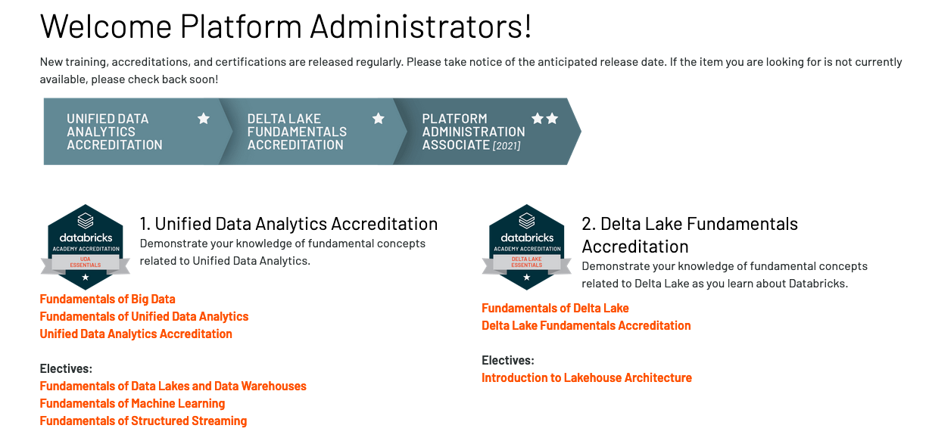

Here are some Quick Links to the different learning paths:

Business Leader

Platform Admin

SQL Analyst

Data Engineer

Data Scientist

Help Center Learning Paths
The Databricks Help Center available on our public website has learning paths that are also geared towards specific roles.

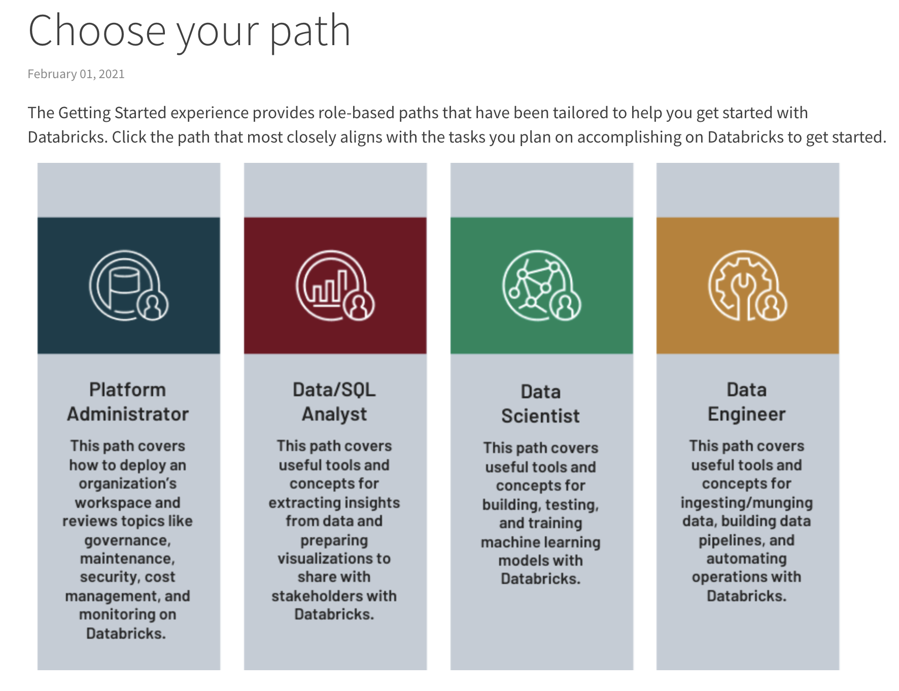

Clicking on the learning path related to the role you are interested in will provide you with a path of links to help pages that provide video tutorials followed by step-by-step instructions for how to do specific activities, such as start a cluster, in Databricks. This is a great place to start once you are ready to dive in and start using the platform.

Here are some Quick Links to the different learning paths:
- Platform Admin
- SQL Analyst
- Data Engineer
- Data Scientist

Databricks Workshops
n-depth training can be provided on several topics by the Account Team to groups. Reach out to the account team to get information on what workshops are available! Below are some examples or workshops that can be provided:
- Delta Lake Workshop
- ML Workshop
- SQL Analytics Workshop
- Performance Workshop
- DevOps and CI/CD Workshop
Workshops give us the chance to go in-depth on important features in Databricks. If you have a need for an in-depth workshop then reach out to the Account Team and let us know!

Keep up with everything happening at Databricks!
Our technical experts are always creating blogs and events to talk about new features and how our customers have used Databricks. Follow us on LinkedIn for upcoming event like Data and AI Summit!
- Databricks Blogs
- Databricks Announcements
- Databricks Events
- Databricks YouTube Channel for Webinars and other videos

Learn about New Features and Releases!
- Platform Release Notes
- Databricks Runtime (DBR) Release Notes
- Databricks Runtime (DBR) Maintenance Updates

